The Requester Guide (New UI)
This document provides a condensed overview of the ESM PurchaseTM Requester Process. It will demonstrate with short text descriptions supported by screen shots for each step explained.
New users of this system are encouraged to contact Office of Procurement Management, Lisa Hubbard, 605-773-4580, lisa.hubbard@state.sd.us, for proper training in creating requisitions/transactions.
Current users are welcome in contacting Lisa if you have questions in creating requisitions/transactions with the new update. Most of the information has been moved from the left side to the right side of the screen with extra information being viewable.

Table of Contents
- Shop
- Non-Catalog Item
- Cart
- Checkout
- All Transactions
- Search Capabilities in All Transactions
- Prepare CC
- Release PO
- View Order
- Re-Release

Shop
The Requester can select various items from assigned catalogs. There are two types of catalogs: Punch-out and Hosted. A Hosted Catalog contains items that are uploaded into ESM Purchase, and a Punch-out Catalog opens a customized version of the Supplier’s website.
If a user opens multiple PunchOut catalog sessions from the Shop page, each session will open in a separate browser window.
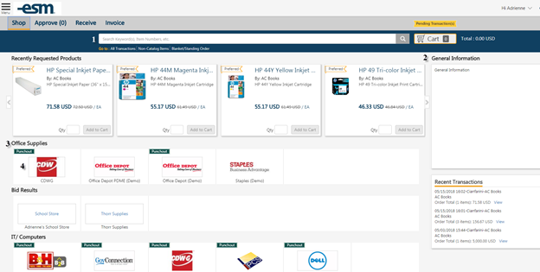
- Search Items: Search for items from assigned catalogs
- Information Box: Entity-wide material determined by Sys Admin
- Category: Header to group catalogs
- Catalog: Icon for easy access to assigned catalogs
The Requester can select a catalog or search for items. The System Administrator may have denoted a supplier as preferred or with a business classification, which will appear in the search results.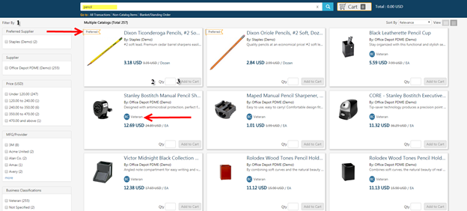
- Filter By: Criteria to narrow down Shopping Results
- Qty: Desired quantity for transaction
- Add to Cart: Select when all quantities are completed
After selecting ‘Add to Cart’, the total quantity of item(s) and price is listed behind the Cart. The Requester can continue to Shop or go to their Cart by selecting either the Cart or View Cart toastr message indicated below.
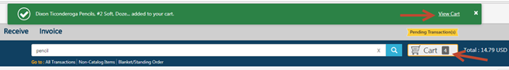
Non-Catalog Item
The Requester creates a Non-Catalog Item by selecting the Non-Catalog option under the Search Bar on the Shop tab. A Non-Catalog Item allows the Requester to create an item that is not provided in the catalogs, if the Supplier has allowed for it.
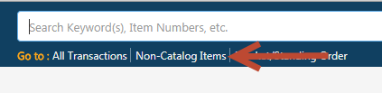
The Requester searches for the Supplier.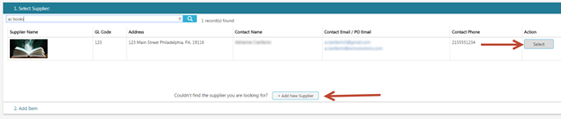

Enter the product detail’s required fields (Item/Service, UOM, Qty, and List Price) to create the item and ‘Add to Cart’.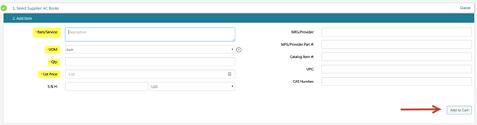
Cart
The Requester can edit the quantity or delete items. Then, Convert Cart to X transaction(s) by selecting Checkout. More than one transactions are created if the items are from multiple Suppliers.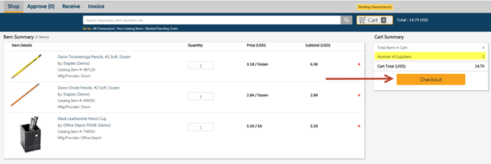
Checkout
The Requester can continue to add items to converted transactions in the Checkout tab, if the Supplier is the same.
Complete each portion of the Checkout sections to complete the order. Select Continue to save/confirm information in each section. The order can be Copied, Deleted, or put on Hold using the icons at the top of the Checkout Screen.
Apply the general details of the order and confirm/modify the default Bill-to and Ship-to locations. Select Continue under each to save and proceed to the next section.
Punchout Catalogs – Innovative, Fastenal, Grainger and Staple
(the steps below do not apply for CDW and Riverside Technologies (RTI) Punchout Catalogs. See Computer Purchases & Punchout Catalogs – CDW & Riverside Technologies (RTI) for the proper steps).
Release Method should be Electronic
Approval Workflow should be Agency Workflow
NIGP Code for Innovative - Office Supplies should be 615; the other punchout catalogs, just select a code that comes closes to what you are purchasing.
Purchase Order # will be the Fiscal Year, followed with a P, for Purchase, and the Transaction Number…example 20PXXXXXX.

Direct Voucher/Credit Card Purchases under $4000 (that are not Punchout Catalogs)
Release Method should be Manual
Approval Workflow should be Agency Workflow
Purchase Order # will be the Fiscal Year, followed with a P, for Purchase, and the Transaction Number…example 20PXXXXXX.
Encumbrance Purchases under $4000 (use this when you want to have the purchase written to the state’s accounting system and processed as a purchase order).
Release Method should be Manual
Approval Workflow should be Encumbrance to OPM
Purchase Order # will be the Transaction Number
GL Acct. Code will need to be active in the state’s accounting system and ESM.
Computer Purchases & Punchout Catalogs – CDW & Riverside Technologies (RTI) under $4000
Release Method should be Manual
Approval Workflow should be Encumbrance to OPM
NIGP Code must be 204
Purchase Order # will be the Transaction Number
GL Acct. Code will need to be active in the state’s accounting system and ESM.
Purchases $4000 and over, including Computer Hardware & Software & Punchout Catalogs – CDW & Riverside Technologies (RTI) (these purchases will be written to the state’s accounting system and processed as a purchase order).
Release Method should be Manual
Approval Workflow should be Agency Workflow
Purchase Order # will be the Transaction Number
GL Acct. Code will need to be active in the state’s accounting system and ESM.

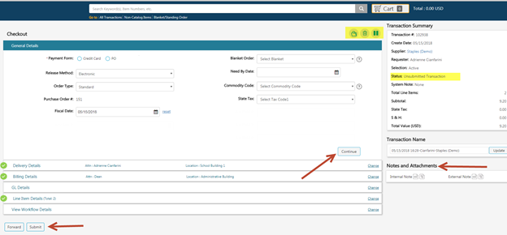
Note: Notes and Attachments included in transaction that can be Internal (Users) or External (Suppliers)
External Note: External Note is information or instructions to the vendor. This information will be printed on the purchase order.
Internal Note: Internal Note is information that can be viewed only by the State Agency and Office of Procurement Management. Information you may want to provide is who the item is for or any other information you may find pertinent to the requisition.
Under GL Details, requesters can select Account Code favorites or New account codes with the drop-down menu and plus sign. If multiple account codes are selected, a split can be entered based on percentage. Select Continue to confirm the GL codes.
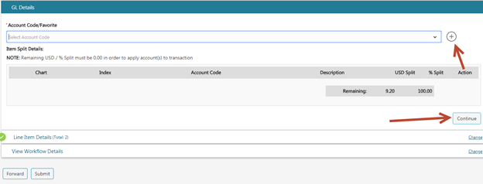
Requesters confirm the final line item details including quantity, note and attachments and Line-item level GL code (use the “more…” link). Select Continue to confirm Line Item Details. 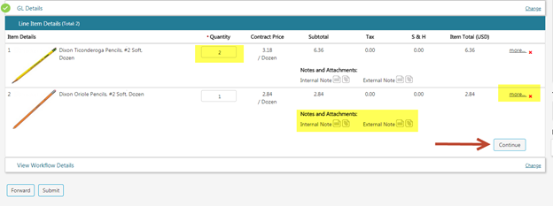
The workflow will generate after the order is validated. If any transaction validation rules are trigger, more information will be listed under the System Note. Once the condition is resolved, the transaction can be re-validated for approval. Select Submit to send the transaction for approval or continue if no approval is required.
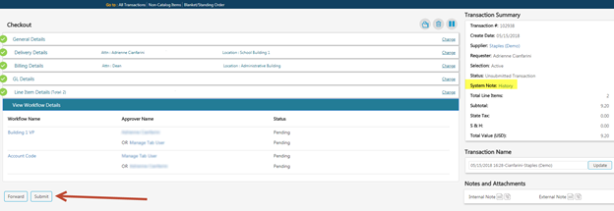
The Requester will submit the transaction through the approval process.
If an entity is configured for the final approver to release transactions to the supplier, the requester will receive an email notification when the release occurs.
Potential actions:
Request Approval: Send through the approval process
View Workflow: Review approvals if required
Prepare CC Order: Enter Credit Card and release transaction to Supplier
Release PO: Release Purchase Order to Supplier
Hold: Pause transaction for later action (Removes from Active Orders)
Delete: Delete transaction from history
Archive: Storing the actions on transaction, but no further action is required
Copy Transaction: Recreate the transaction (New Transaction/PO Number assigned)

All Transactions
Users are able to track the progress or view previous transactions by selecting All Transactions below the search bar. To open a transaction, select the transaction name. 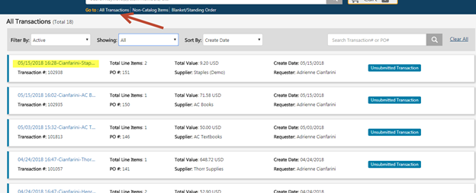
The Requester can monitor the Status of the Transaction to review its current state.
Statuses can include, but are not limited to:
Unsubmitted Transaction: Pending Next Step option of Request Approval or Release PO (if no approval necessary)
Pending Approval: In approval process
CC Information Required: Credit Card is needed before release
Pending Release: Ready to release
Approval Rejected: Rejected by Approver
Submitted to Supplier: Transaction successfully sent to Suppler

Search Capabilities in All Transactions
The Requester can review all his/her created transactions by using the provided search criteria. Any changes to the selection/sort by will remain the default until updated.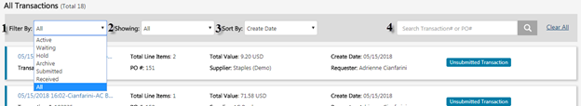
- Filter by: Search filter to indicate next user/system action (expanded above) (original default of Active)
  - Active: The user’s action is needed
  - Waiting: Waiting on another user/system action
  - Hold: Paused transactions for later action
  - Archive: Transactions with stored actions
  - Submitted: Transactions sent to Supplier
  - Received: Transactions with items obtained
  - Ad Hoc: Transactions waiting on additional approver
  - All Last 30 days, All Last 90 days, All: Transactions within specified date range
- Showing: Search filter Date ranges; 7 Days, 30 Days, 60 Days, 90 Days, or All
- Sort by: Determines the displayed order of transactions by Acct #, Create Date, Payment Form, PO #, Transaction #, Transaction Name, Status, Supplier (A-Z), (Supplier Z-A), or Recently Added (original default of Recently Added)
- Search Bar: Locate a specific transaction with the Transaction or Purchase Order Number.

Prepare CC Order
If the entity is configured to have the requester release the order to the supplier, an email notification will be sent and an action button will appear after the final approval within the requester's All Transactions screen. To enter credit card information for an order, select Prepare CC Order.
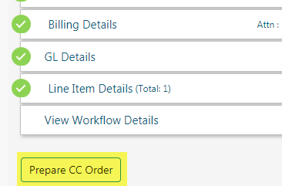

The user will be presented with a review of the order and the opportunity to print. Select Place Order to enter CC information.
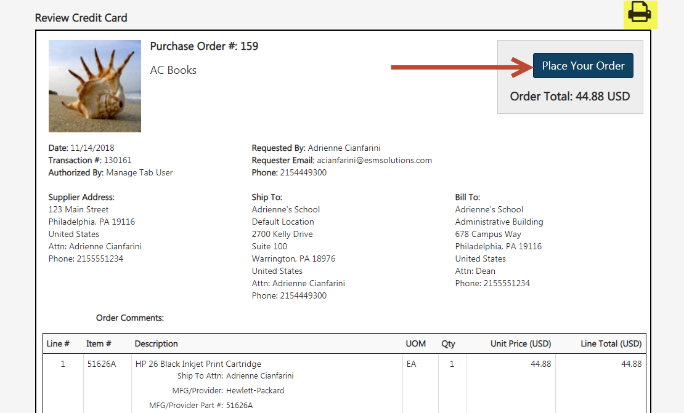

Enter the card information and select Place Order and confirm the pop-up.

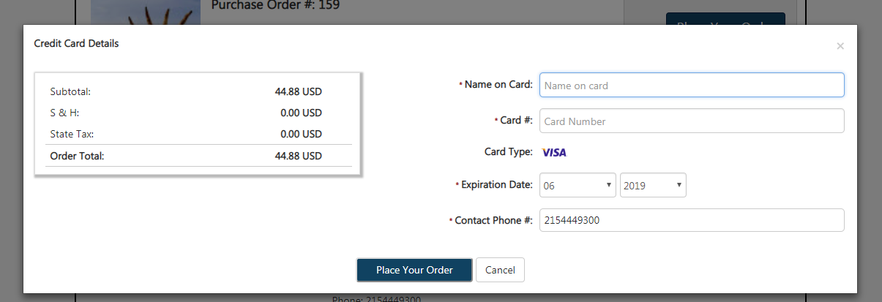

Release PO –

Requestors will receive an email message from ESM Solutions stating the Transaction is complete and that you must now share a copy of the purchase order to the Supplier/Vendor.

Requestors can only release purchase orders under $4000 that were not processed through Office of Procurement Management and the Punchout Catalogs such as: Innovative, Fastenal, Grainger and Staples. Office of Procurement Management will release all other purchase orders to the supplier/vendor and to the agency contact person.
If the entity is configured to have the requester release the order to the supplier, an email notification will be sent and an action button will appear after the final approval within the requester's All Transactions screen. To release an order, select the Release PO Action button. The user will be prompted to review the order and select Continue.
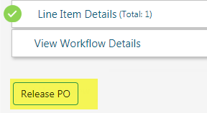
The user is presented with a copy of the order to review, select Place Order and confirm release.
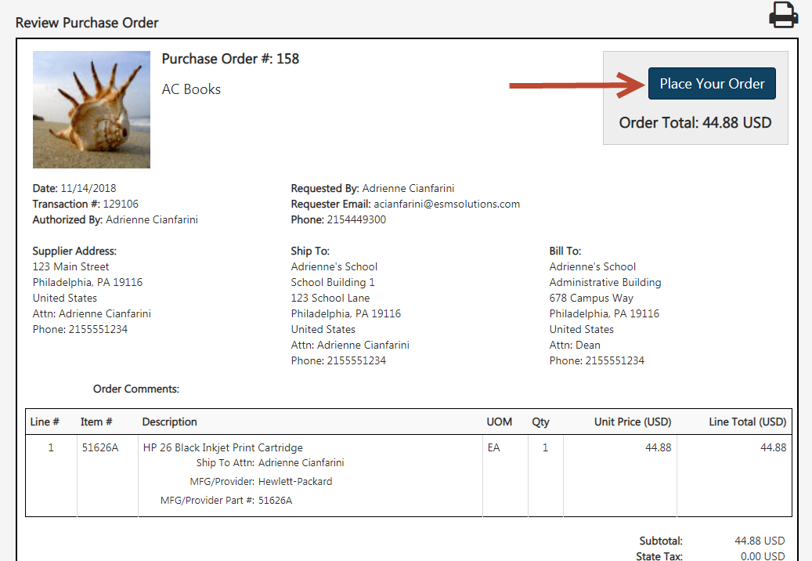
When successfully submitted, the order will appear under the Selection filter “Submitted with the Status of “Submitted to Supplier.”

View Order
The user may select the View Order icon under the All Transactions/Approve/Manage screen.
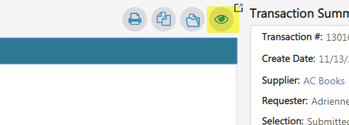

The System Note History states the time the order was successfully released.
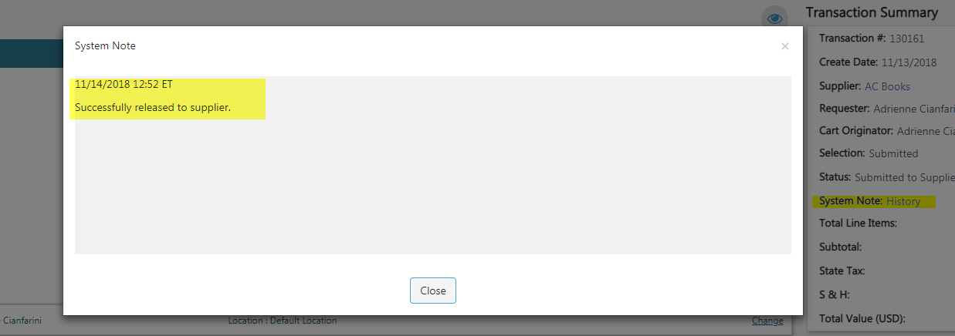

Re-Release Order
Locate the order using the Filter By Option or the Search bar and select the Transaction Name to open the order.
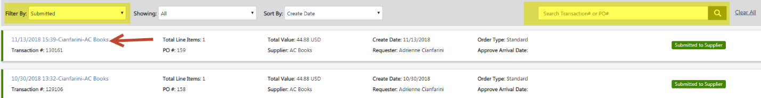

Select Re-Release Order.
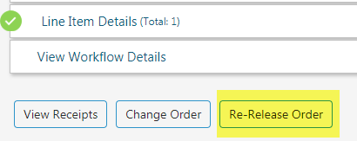

Select Place Order and confirm based on payment type. If the Payment Form is Credit Card and it was declined, provide new card information. Select Continue and Place Order.
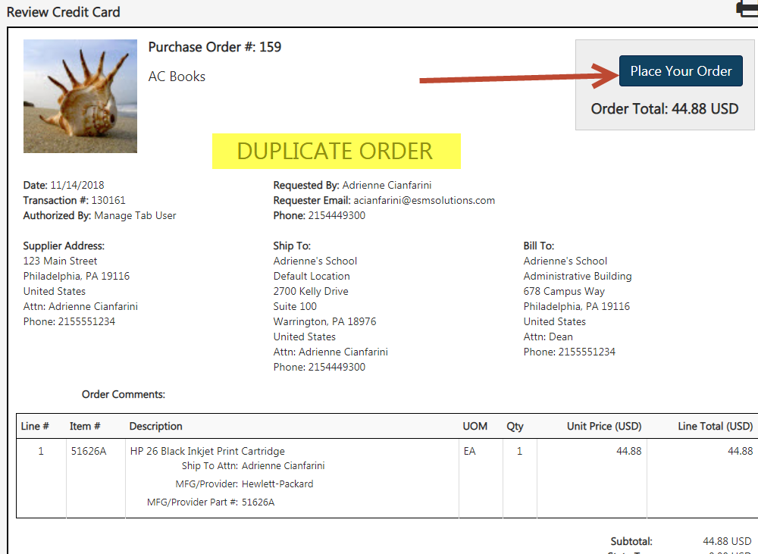
Note: Re-released orders will state “Duplicate Order.”

