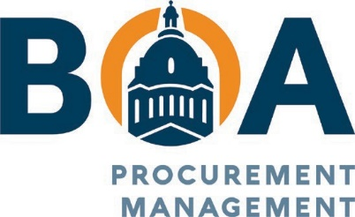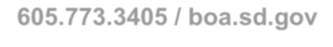

523 East Capitol, Pierre, South Dakota 57501
605.773.3405 / boa.sd.gov

Solicitation: IFB #2304 – Furniture & Related Products

Name of Manufacture: The HON Company

MODULAR/SYSTEMS
Order Amount $ | Outside/Doc Delivery | Inside Delivery | Installation
$1 to $4,999 | 64.7% | 63.8% | 60.6%
$5,000 to $49,999 | 65.7% | 64.8% | 61.7%
$50,000 to $99,999 | 65.7% | 64.8% | 61.7%
$100,000 and above | 67.9% | 65.8% | 62.8%
SEATING
Order Amount $ | Outside/Doc Delivery | Inside Delivery | Installation
$1 to $4,999 | 53.3% | 52.1% | 47.9%
$5,000 to $49,999 | 55.0% | 53.8% | 49.8%
$50,000 to $99,999 | 55.0% | 53.8% | 49.8%
$100,000 and above | 59.6% | 56.9% | 53.2%
DESKS
Order Amount $ | Outside/Doc Delivery | Inside Delivery | Installation
$1 to $4,999 | 53.3% | 52.1% | 47.9%
$5,000 to $49,999 | 55.0% | 53.8% | 49.8%
$50,000 to $99,999 | 55.0% | 53.8% | 49.8%
$100,000 and above | 59.6% | 56.9% | 53.2%

TABLES
Order Amount $ | Outside/Doc Delivery | Inside Delivery | Installation
$1 to $4,999 | 53.3% | 52.1% | 47.9%
$5,000 to $49,999 | 55.0% | 53.8% | 49.8%
$50,000 to $99,999 | 55.0% | 53.8% | 49.8%
$100,000 and above | 59.6% | 56.9% | 53.2%
BOOKCASES/STORAGE
Order Amount $ | Outside/Doc Delivery | Inside Delivery | Installation
$1 to $4,999 | 55.4% | 54.2% | 50.3%
$5,000 to $49,999 | 56.4% | 55.2% | 51.4%
$50,000 to $99,999 | 56.4% | 55.2% | 51.4%
$100,000 and above | 63.7% | 61.3% | 57.9%
EDUCATIONAL
Order Amount $ | Outside/Doc Delivery | Inside Delivery | Installation
$1 to $4,999 | 53.3% | 52.1% | 47.9%
$5,000 to $49,999 | 55.0% | 53.8% | 49.8%
$50,000 to $99,999 | 55.0% | 53.8% | 49.8%
$100,000 and above | 56.5% | 53.8% | 49.8%
HEALTHCARE
Order Amount $ | Outside/Doc Delivery | Inside Delivery | Installation
$1 to $4,999 | 51.3% | 50.0% | 45.7%
$5,000 to $49,999 | 52.3% | 51.0% | 46.8%
$50,000 to $99,999 | 52.3% | 51.0% | 46.8%
$100,000 and above | 54.5% | 51.5% | 47.3%

DESIGN SERVICES
These are optional services through the manufacturer and or their local dealers. Contact the manufacturer and or dealer for services they will provide at the rate listed below.
The HON Company – Manufacture | Not to exceed $55.00/Hour

