**VEHICLES**

2019 DODGE RAM 1500 CREW CAB

2018 DODGE RAM 1500 CREW CAB

2017 DODGE RAM 1500 CREW CAB (3

2016 DODGE RAM 1500 CREW CAB (2

2016 FORD EXPLORER POLICE

2015 DODGE RAM 1500 CREW CAB

2013 DODGE RAM 1500 CREW CAB

2011 CHEVY 1500 EXT CAB

2009 CHEVY IMPALA (2)

2008 CHEVY IMPALA

2007 CHEVY IMPALA

2006 CHEVY IMPALA

2006 FORD TAURUS

2005 FORD TAURUS SE

**RECREATIONAL**

2010 CLUB CAR GOLF CART

2008 KAWASAKI 610 MULE

2002 CLUB CAR GOLF CART

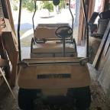

1996 CLUB CAR GOLF CART

1995 SHORELANDR JETSKI TRAILER

4 SCOOTERS-ABANDONED ITEMS

**EQUIPMENT**

2017 GRASSHOPPER 932 61” MOWER

2017 KUBOTA ZD1511 72” MOWER

2013 KUBOTA ZD331 72” MOWER

**EQUIPMENT CONTINUED**

2012 BOBCAT S205 SKID LOADER

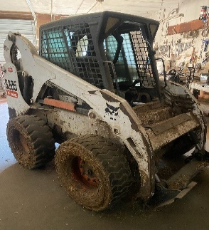

2007 TARNEL 24’ GOOSNECK TRAILER

2008 CASE 162RDX WINROWER HEAD

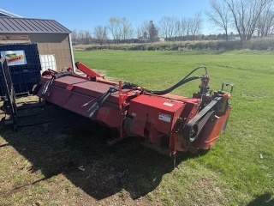

8X14 FLATBED TRAILER

4X8 FLATBED TRAILER

7X16 FLATBED TRAILER

6X8 FLATBED TRAILER

PICKUP MOUNT SNOW PLOW

MOWER MOUNT JD SNOW BLOWER

TORO SNOW BLOWER

TROY BUILT SNOW BLOWER

WALK BEHIND SICKLE MOWER

SEAD CLEANER

2003 KUBOTA L3010 UTILITY TRACTOR WITH LOADER

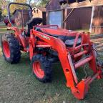

**EQUIPMENT CONTINUED**

1995 DCT 8X24 GOOSENECK TRAILER

BUFFALO CULTIVATOR

TONNEAU COVER FOR 2024 FORD

BETTER BUILT ALUMINUM TOOL BOX

OLIVER PLANER #166-BD

J-LINE LATHE

CRAFTSMAN BELT SANDER W/STAND

DELTA ROCKWELL RADIAL ARM SAW

DELTA SHAPER

MILWAUKEE JIG SAW

ROCKWELL PLANER

ADVANCE WET VAC

DELTA SCROLL SAW

SENCO FRAMING NAILER

CLEVELAND STEAMCRAFT ULTRA 10

PINNACLE REFRIG. RECOVERY UNIT

MISCELLANEOUS TOOLS

**OFFICE, HOME, KITCHEN EQUIPMENT**

NESCAFE COFFEE MAKER (3)

VITALITY JUICE DISPENSER EX-48EPH

4X6 TABLES (6)

NUMEROUS CHAIRS

CABINETS

TABLES

DESKS

ELECTRIC ORGAN

BOOK SHELVES

MISC ENGINEERING EQUIPMENT

TERRARIUMS

OLD TOLEDO SCALE

AND MUCH, MORE. THIS IS A LARGE AUCTION WITH SOMETHING FOR EVERYBODY. **WE WILL BE SELLING TWO RINGS!! COME PREPARED**