**VEHICLES**

2019 CHEVY MALIBU

2019 DODGE 1500 (2)

2018 CHEVY TAHOE 4X4 (2)

2018 DODGE CHARGER POLICE

2018 DODGE 1500

2017 CHEVY MALIBU

2017 FORD TAURUS

2016 CHEVY IMPALA (3)

2015 CHEVY IMPALA

2015 CHEVY 1500 4X4

2015 CHEVY 3500 VAN

2014 CHEVY IMPALA

2014 CHEVY TAHOE POLICE

2013 CHEVY IMPALA (3)

2013 CHEVY 3500 VAN

2012 CHEVY IMPALA

2012 CHEVY SUBURBAN 1500 4X4

2011 CHEVY 1500 4X4

2011 CHEVY 1500 4X2 (2)

2011 CHEVY TAHOE POLICE

2011 DODGE RAM 2500 4X4

2010 CHEVY IMPALA

2009 CHEVY SUBURBAN 2500 4X4

2008 CHEVY IMPALA (2)

2008 DODGE DURANGO 4X4

2008 FORD F250 4X4 (2)

2007 CHEVY IMPALA

2007 CHEVY SUBURBAN 2500 4X4

2007 F150 LONG BOX 4X4

2006 CHEVY 1500 4X4 (2)

2003 F350 REG CAB 4X4

2001 DODGE 3500 4X4

2001 F250 4X4

2000 DODGE VAN 3500

1998 FORD E150 VAN

**EQUIPMENT & MISCELLANEOUS**

2016 WARN SPRAYER

2015 INDUSTRIAL PARTS WASHER

**EQUIPMENT & MISC. CONTINUED**

2014 HUSQVARNA RIDING MOWER

2014 SKID LOADER SNOW BLOWER

2013 ALAMO 15’ BATWING MOWER

2012 KUBOTA MOWER NEEDS REPAIR

2003 UTILITY TRAILER 10’

2003 GEHL SKID LOADER

2003 JOHN DEERE F687 JD MOWER

2001 TRAILKING 32’ PINTLE HITCH TILT BED TRAILERS (2)

2001 NEW HOLLAND LW170 LOADER

2001 JOHN DEERE MOWER

1997 JOHN DEERE LX188 MOWER

1979 TRAILER WITH 400 GALON TANK

JOHN DEERE UTILITY TRACTOR

J D 1545 72” FRONT DECK MOWER

J D 1570 72” FRONT DECK MOWER

LINCOLN 3 PHASE ARC WELDER

STIHL WEED EATERS (3)

FMC 7600 TIRE MACHINE - NICE

BACK PACK MOSQUITO FOGGER

ARIENS WALK BEHIN WEED TRIMMER

PAINT SPRAYER W/HONDA MOTOR

J D PRESSURE WASHER

SKID STEER BROOM

BOBCAT SNOW BLOWER

SKID STEER MOUNT SNOW BLOWER

BOBCAT JACK HAMMER

BOBCAT ATTACHMENT PLATE

SKID STEER MOUNT AUGER & BITS

BED GLIDE TOOL BOX

FIRE EXTINGUISHERS

SELF CONTAINED BREATHING UNITS

DRILL PRESS

DRAFTING TABLE

ONAN GENERATOR

MEDICAL EXAM TABLE

CONCRETE TESTING CYLANDERS (18)

ASSORTED TESTING SCALES

SERVICE TYPE PICKUP TOPPER (2)

**RECREATIONAL**

2016 JOHN DEERE GATOR

2014 YAMAHA 4 WHEELER

2013 CUB CADET

2013 POLARIS RANGER 6X6

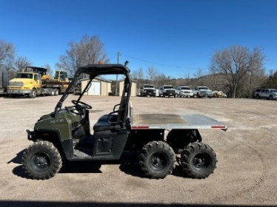

2011 KAWASAKI 600 MULE

2009 YAMAHA BIG BEAR 4 WHEELER

2009 125 KAWASAKI MOTORCYCLE(2)

2008 GZ250 SUZUKI MOTORCYCLE (7)

2001 GZ250 SUZUKI MOTORCYCLE (4)

GROUND HOG ARENA GROOMER 3PT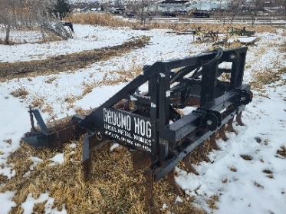

20HP MERC OUTBOARD MOTOR

GARMIN HANDHELD GPS (10)

SIG P226 AIRSOFT PISTOL (11)

10 BUCKETS USED 223 40 9MM BRAS

NUMEROUS HOLSTERS P226/OTHERS

X2 TRAINING TASERS (29)

SIG P226 TRAINING PISTOLS (26)

.40 CALIBER DUMMY ROUNDS +-60

SIG P226 DROP HOLSTER KITS (6)

SIG P226 9MM AND .40 MAGS

**PLUS TABLES, CHAIRS, DESKS, CABINETS, ELECTRONICS, TOOLS, AND MANY OTHER MISCELLANEOUS ITEMS!!!**

**CAN’T WAIT TO SEE YOU ALL THERE**